**The laboratory work 1**

**Creating virtual machines in Azure**

**Getting Started with Microsoft Azure Virtual Machines**

**Introduction**

You can use a Microsoft Azure Virtual Machine when you need a scalable, cloud-based server running a Windows or Linux operating system and any application of your choosing. By taking advantage of Microsoft Azure Infrastructure as a Service (IaaS), you can run a virtual machine on an ongoing basis, or you can stop and restart it later with no loss to your data or server settings. You can quickly provision a new virtual machine from one of the images available from Microsoft Azure. On the other hand, if you are already running applications in a VMware or Hyper-V virtualized environment, you can easily migrate your virtual machine to Microsoft Azure. Once you have created your virtual machine and added it to Microsoft Azure, you can work with it much like an on-premises server by attaching more disks for data storage or by installing and running applications on it. Virtual machines rely on Microsoft Azure Storage for high availability. When your virtual machine is provisioned, it is replicated to three separate locations within the data center to which you assign it. You have the option to enable geo-replication to have copies of your virtual machine available in a remote data center region.

**Considering Scenarios for a Virtual Machine**

Microsoft Azure gives you not only the flexibility to support many application platforms, but also the flexibility to scale up and scale down to suit your requirements. Furthermore, you can quickly provision a new virtual machine in a few minutes. A Microsoft Azure virtual machine is simply a fresh machine preloaded with an operating system of your choice—you can add any needed application easily. Consider the following suggested scenarios as merely a few of the possibilities.

**Existing virtual environment.** You can move an existing server workload into the cloud simply by copying an existing on-premises VHD to Microsoft Azure. That way, you can leverage cloud benefits such as elasticity, redundancy, and automatic platform updates, while paying only for storage and the time the virtual machine is in use.

**Cloud workstation**. You can create a virtual machine for use in the cloud that contains applications you commonly use and want to access from any location. Rather than set up a desktop workstation or carry a laptop to run the applications you use frequently, you can install your applications on a virtual machine that is accessible in the cloud. With this type of environment, you can travel easily from location to location with a tablet and then connect to a virtual machine using RDP or SSH to access your routinely used applications such as Matlab, R, IPython, or SQL Server.

**Linux cluster**. You can create a virtual machine based on a Linux operating system and then change the configuration to run multiple virtual machines as a cluster. By using a cluster, you provide a fast, high capacity, and redundant environment for any custom Big Data and Big Compute applications you choose to install on the virtual machine.

**Development or test environment**. Another option is to set up virtual machines for development or test purposes that you use solely on an as-needed basis. For example, you could install Visual Studio on a virtual machine for use during the development phase of a project without the need to allocate on-premises resources to development. Likewise, rather than incur the cost of setting up and maintaining a load test environment that you use only periodically, you can set up virtual machines to run only when you need an independent and isolated environment.

**Creating a Virtual Machine**

|  |
| --- |
| There are two primary ways to create a virtual machine that runs in Microsoft Azure—mounting an existing disk or using an image.  A disk is a virtual hard disk (VHD) that already contains an operating system at minimum and optionally includes one or more applications. Any configuration changes you make are persisted on the disk and available the next time you start the VHD. |
| An image is a template that contains a base operating system (Windows or Linux) and perhaps one or more applications, but no user accounts. A disk for the operating system is added to Microsoft Azure Storage and assigned to the new virtual machine during the provisioning process. You can use an image to quickly reproduce the same virtual machine multiple times. |

**Using the Virtual Machine Image Gallery**

A simple way to get started using a virtual machine is to create virtual machine from the Image Gallery that you can access from the Microsoft Azure Management Portal. To view the available images, click the New button (which displays as a plus symbol on the bottom left side of the portal), select Virtual Machine in the Compute group, and then click From Gallery, as shown in Figure 1.



The Create a Virtual Machine dialog box gives you the following three options:

* **Platform Images**. Here you can find a collection of images, as shown in Figure 2, containing only an operating system, such as Windows Server 2012 R2 or OpenLogic CentOS 6.3, or images that contain both an operating system and an application, such as SharePoint Server 2013 or Visual Studio Ultimate 2013. For a list of supported operating system roles and features as well as supported software, see http://support.microsoft.com/kb/2721672.
* **My Images**. This section of the Image Gallery displays a list of images that you create and store in Microsoft Azure. To create an image, you can capture an existing Microsoft Azure Virtual Machine, use SUSE Studio to build and migrate an image, or upload your own virtual machine, as explained later in this document.
* **My Disks**. You can create a virtual machine simply by selecting a disk on this list.



After you select the image you want, you assign a name to the virtual machine, specify a size, and create the administrator’s login name and password for a Windows operating system or specify the authentication method for a Linux operating system. Some platform images have minimum size recommendations noted in the image description. The number of CPU cores and the amount of available memory defines the size of a virtual machine. At one end of the spectrum, a virtual machine can share a CPU core, consume only 768 MB of memory, and support one data disk. The maximum size of a data disk is 1 TB. At the other end of the spectrum, a virtual machine can be allocated eight CPU cores, up to 56 GB of memory, and up to 16 data disks at the time of this writing, but these maximum values are likely to increase as Microsoft Azure adds more powerful hardware offerings in the future. Pricing of the virtual machine depends on the size of the virtual machine you select.

Your next step is to configure the following additional settings for your virtual machine:

**Cloud Service**. A cloud service is simply a container for your virtual machines. You can host a single virtual machine in a cloud service or assign multiple virtual machines to the same cloud service. When configuring the cloud service, you can request a new cloud service or select one that you created earlier.

**Cloud Service DNS Name**. You must provide a unique name that you later use to connect to the virtual machine.

**Subscription**. You must assign the virtual machine to an existing subscription.

**Region/Affinity Group/Virtual Network**. You must select a data center region to host your virtual machine. Alternatively, if you have created an affinity group or virtual network, you can select either of those options instead.

**Storage Account**. The disk for your virtual machine that gets created from the image you select must be assigned to a storage account. You can create a new one for your virtual machine or select a storage account that you created earlier.

**Availability Set**. An optional step is to create an availability set or assign the virtual machine to an existing availability set to ensure high availability. That way, if your physical server is taken down for maintenance, every service included in the availability set will be accessible through other physical hosts. When multiple virtual machines belong to the same availability set, the Microsoft Azure Fabric Controller places virtual machines across multiple racks, each of which can be considered a fault domain and separate physical points of failure, as shown in Figure 3. In addition, each virtual machine is placed in a separate upgrade domain so that virtual machines in the same availability set are not taken offline at the same time during host updates.



Last, you configure endpoints for your virtual machine. The image you select has one or more preconfigured endpoints. For example, if the image runs a Windows operating system, the Remote Desktop and PowerShell endpoints are created with public and private ports to use when you or your applications connect to the virtual machine. You can add more endpoints if necessary, such as FTP, SSH, or SMTP for example, and specify whether to assign the TCP or UDP protocol to the endpoint. Additionally, you can change the public and private port numbers from the defaults to alternate values. You can also take advantage of advanced networking features in Microsoft Azure Virtual Network to connect your virtual machine to an on-premises datacenter or a single client machine using an IPsec connection.

When you complete the configurations steps, the virtual machine is provisioned in Microsoft Azure. You can monitor this process, which typically takes only a few minutes, in the Microsoft Azure Management Portal. When provisioning is complete, the virtual machine starts. When its status changes to Running, your new virtual machine is available for you to connect to it as described in the “Using a Virtual Machine” section of this document.

If you are not ready to start working with your virtual machine, select it in the list on the Virtual Machines page in Microsoft Azure Management Portal, and then click Shut Down. That way, you can save usage costs, although there is an ongoing cost associated with the disk in your Microsoft Azure Storage account.

**Building virtual machines**

Azure virtual machine architecture

The virtual machine consists of the following parts that are related to each other.

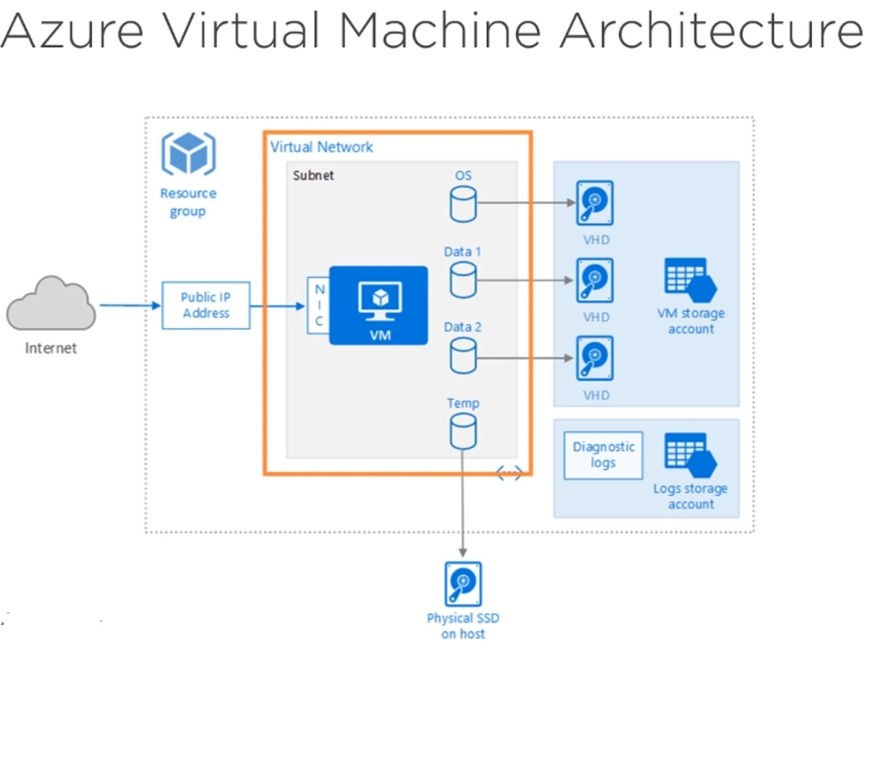

**Creating Windows virtual machine**

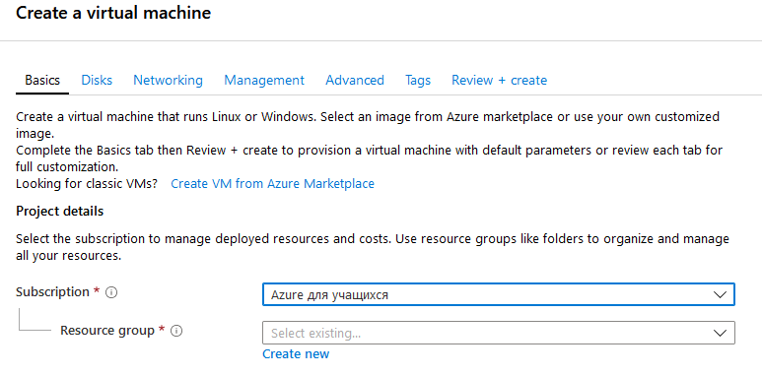

You need to specify the virtual machine’s name, administrator’s login and password, the region where the virtual machine will locate. Then go to selection of the virtual machine’s disks and create HDD or SSD drive on it.

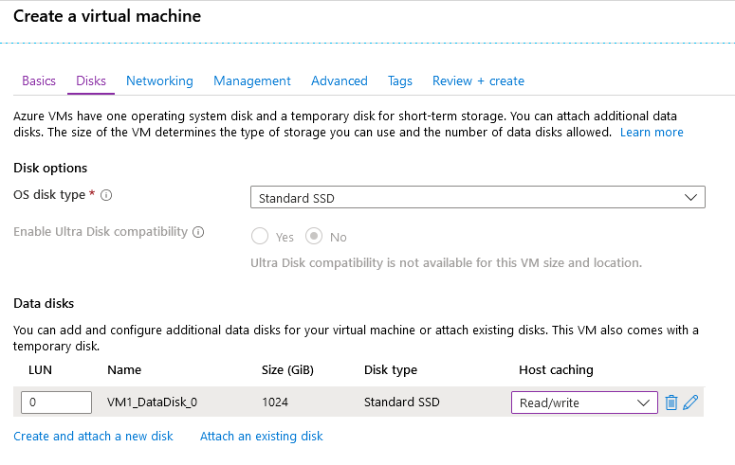

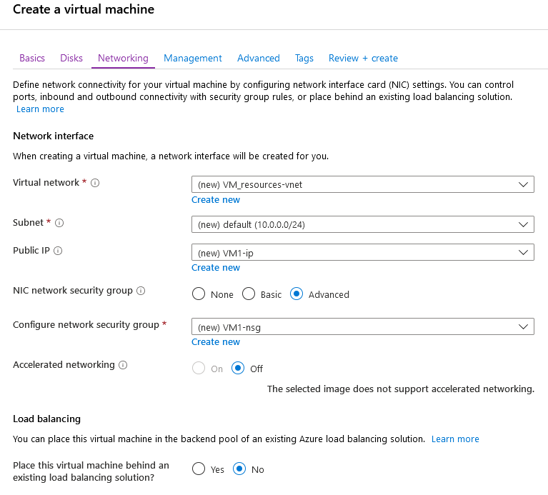

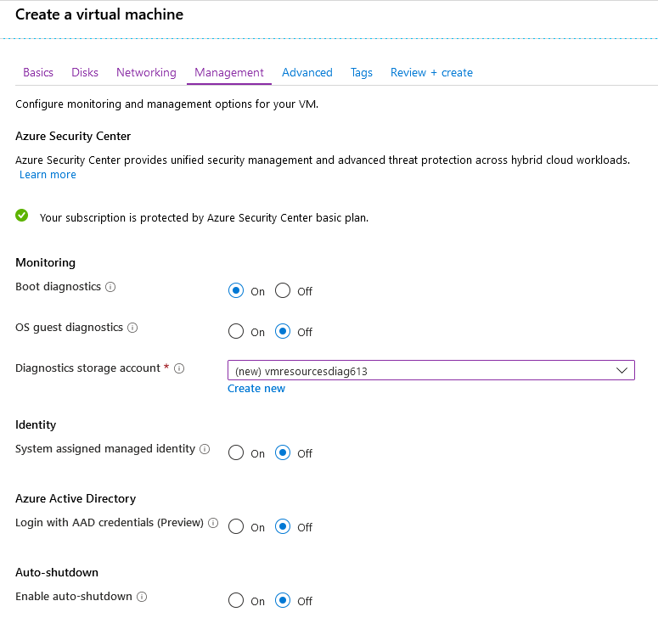

**After choosing all other options finalize the creation of the virtual machine**

